**COEN 317**

**Microprocessor Systems**

**EXPERIMENT #2**

**AND Array Implemented in Programmable Logic**

**Name : Nicholas Gattuso**

**Section : U-UI**

"I certify that this submission is my original work and meets the Faculty’s Expectations of Originality",

# Objectives

The objectives of the lab are to become familiar with the Xilinx ZC702 development board, specifically with its programmable logic. Additionally, it is also to gain experience with the PlanAhead tools, the Xilinx Platform Studio, and the SDK.

# Introduction

# In this lab, we are asked to create the AND gate of two 8-bit inputs. A 16-bit wide GPIO will be used to provide the data to the AND gate. The outputs of the AND gate will be displayed on the development board’s LED.

GPIO stands for general-purpose input and output. It is a pin on the board that can be controlled by the programmer at run time.

For more information on the lab including a block diagram of the system, please refer to the lab manual.

# Results

Similarly to Lab 1, this lab is also directed to introduce us to the development board. For that reason, there isn’t much to show in terms of results nor much processes to explain. The lab required us to follow the detailed steps of how to setup the programs and what to write. However, it is important to understand the procedures and the connections that we are setting.

In PlanAhead, we created a RTL Project that uses a VHDL file and a UCF file. The VDHL file will program the board to read two 8-bit inputs and AND them to an 8-bit output. The UCF file will tell the program which GPIO ports to use as inputs and as outputs. From there, we then created a system in XPS. This system sets up our IO connections. Lastly, before synthesizing, implementing, and generating the bitstream on PlanAhead, we modify the system_stub so that the newly input and output values can be included. This is important so that the UCF ports can match.

In the end, I managed to get my “AND” program to run successfully and was able to see the 8 LEDs light according to the output in the program.

# Question

We are asked to change the values in the two input arrays and observe the resulting changes in the LEDs. To assure that the program output and what we are observing is correct, we can perform the AND of A and B ourselves. The output is 1 if and only if the two input bits are a 1. Therefore, I decided to make all my input bits 1 and check to see if all the LEDs are lit. The following image is the output from the LEDs.

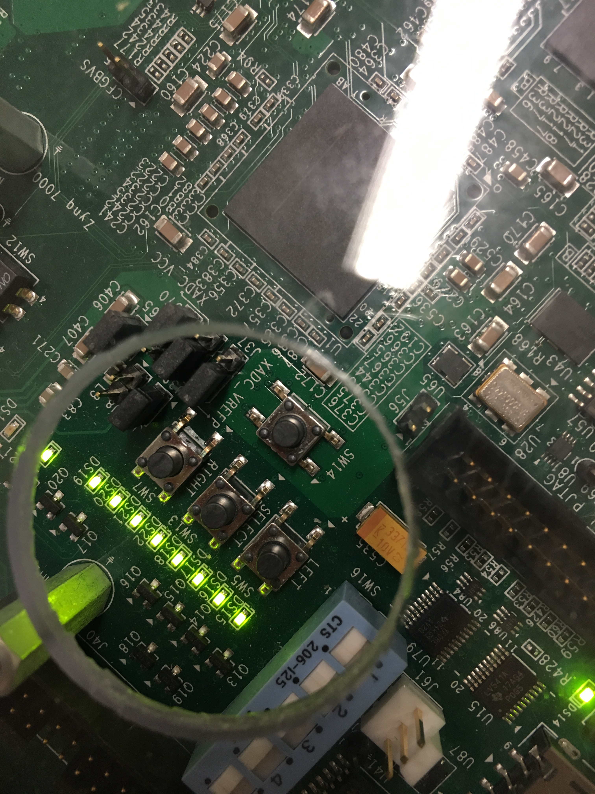

# Conclusion

In conclusion, the objectives of the lab were met. I managed to learn how to use the programmable logic within the Xilinx ZC702 board. I also managed to gain experience and practice with PlanAhead and Xilinx Platform Studio.